full-range speaker B2S
2” 2”
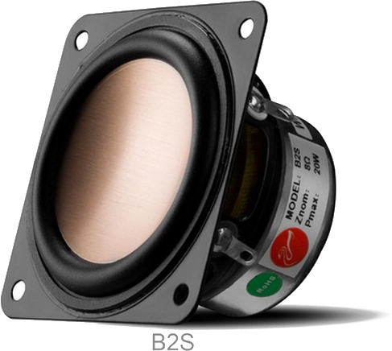
1.5” 1.5”
1” 1”
0.5” 0.5”
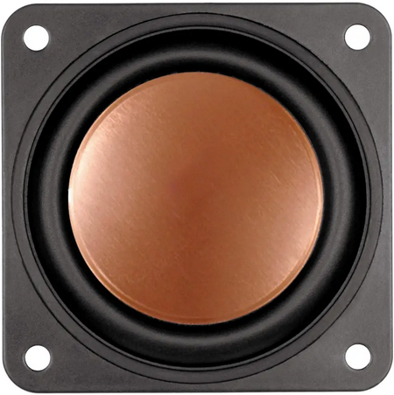
0”
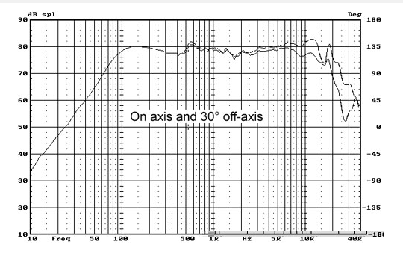 | Specification  Rated Impedance 8Ω  Resonance Frequency 152Hz  Rated Power 10W  Peak Power 20W  Sensitivity(2.83V/1m) 78dB  Weight 0.12kg  Diameter 25mm  DC Resistance 6.5Ω  Width 6.0mm  Coil wire CCAW  Frame Kapton  Material Ferrite  BL Value 2.5 N/A  Magnetic gap height 3.0mm  Xmax 1.5mm  Compliance 689uM/N  QMS 5.69  QES 1.53  Qts 1.2  Mms  Vas 0.2L  SD(cm²) 13,53  Recommend Cabinet  Closed
