Mid-bass speaker M6N
6”
5”
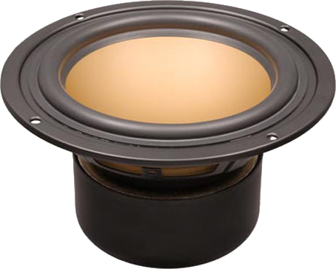
4”
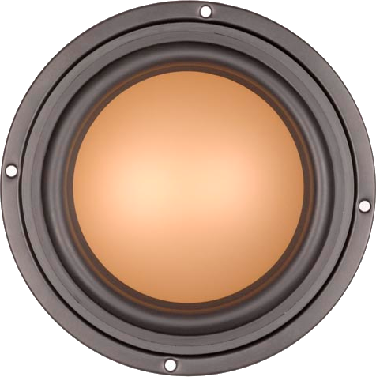
2”
0”
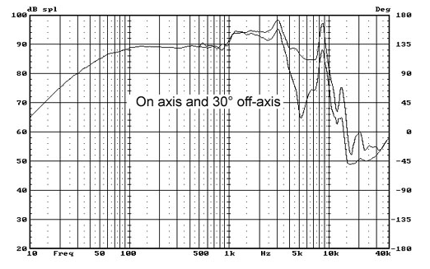  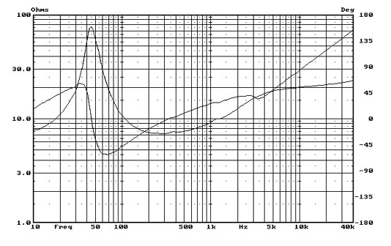  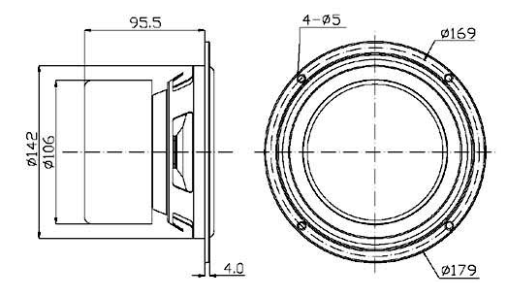 | Specification  Rated Impedance 8ohm  Resonant Frequency 46H z  Rated Power 45W  Max Power 90W  Sensitivity2.83v/1m） 89dB  Coil diameter 25mm  Coil Roll With 14.5mm  DC resistance 6.5ohm  coil wire High temp. SV wire  Coil frame High temp. Kapton  Magnet High perf. ferrite  Force coefficient 7.8N/A  Magnetic gap height 6.0mm  Xmax 4.3mm  Compliance 871uM/N  Mechanical Q value 4.69 -  Electric Q value 0.42 -  Total Q value 0.39 -  Vibration Quality 13.6g  Equivalent volume 21.9L  SD(cm²) 127,68  Cabinet type Inverted  Free Volume 14L  Frequency Field -3db Frequency 46Hz

