Mid-bass speaker D6.8B
6”
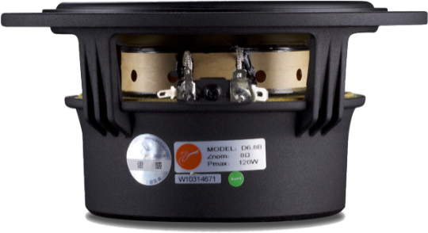
5”
4”
2”
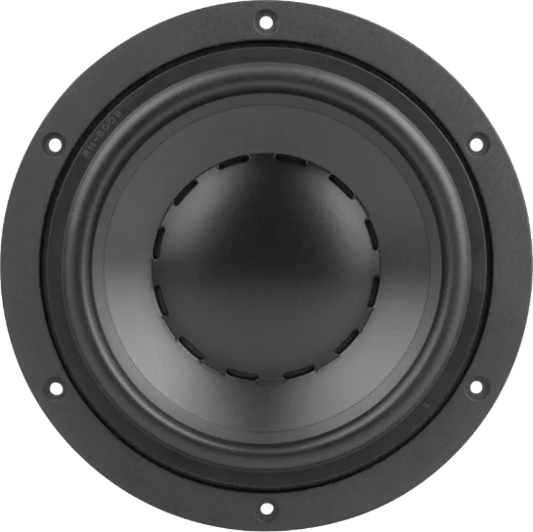
0”
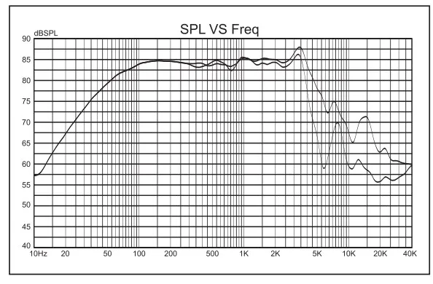  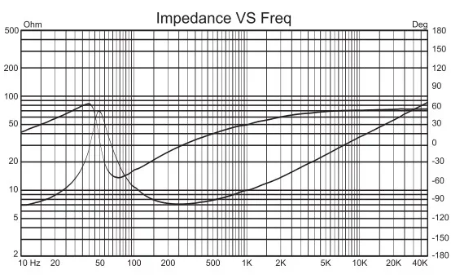  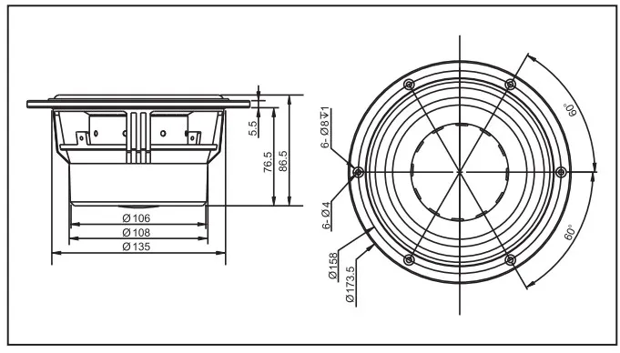 | An identifying mark:  Rated Impedance 8ohm  Resonant Frequency 43H z  Rated Power 60W  Max Power 120W  Sensitivity(2.83v/1m） 85dB  Coil diameter 76mm  Coil Roll With 15.5mm  DC resistance 6.5ohm  coil wire CCAW  Coil frame High temp. Kapton  Magnet High perf. NdFeB  Force coefficient 8.9N/A  Magnetic gap height 5.0mm  Xmax 5.3mm  Compliance 647uM/N  Mechanical Q value 5.21 -  Electric Q value 0.49 -  Total Q value 0.45 -  Vibration Quality 21.9g  Equivalent volume 13.5L  SD(cm²) 120,76  Cabinet type Inverted  Free Volume 10L  Frequency Field -3db Frequency 44Hz

