Mid-Bass speaker B4N
4”
3.5”
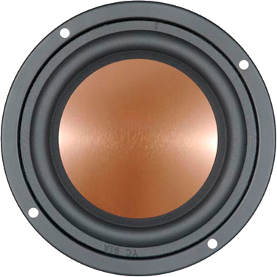
3”
1.5”
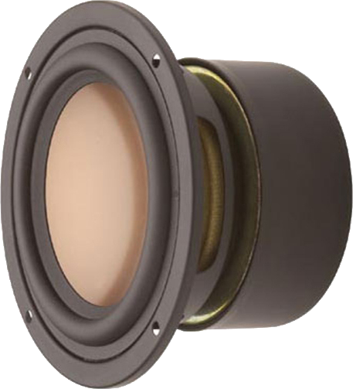
0”
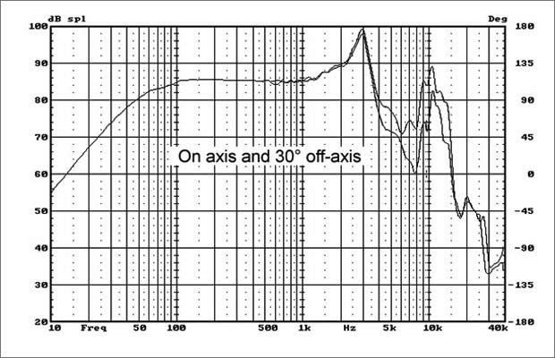 | Specification  Rated Impedance 8ohm  Resonant Frequency 56H z  Rated Power 25W  Max Power 50W  Sensitivity2.83v/1m） 85dB  Coil diameter 25mm  Coil Roll With 10.4mm  DC resistance 6.5ohm  coil wire High temp.SV wire  Coil frame High tem. Kapton  Magnet High per. ferrite  Force coefficient 5.1N/A  Magnetic gap height 4.0mm  Xmax 3.2mm  Compliance 1114.1uM/N  Mechanical Q value 3.91 -  Electric Q value 063 -  Total Q value 0.52 -  Vibration Quality 6.8g  Equivalent volume 4.5L  SD(cm²) 52,81  Cabinet type Inverted  Free Volume 5L  Frequency Field -3db Frequency 50Hz
