Mid-bass speaker L6-4R
6”
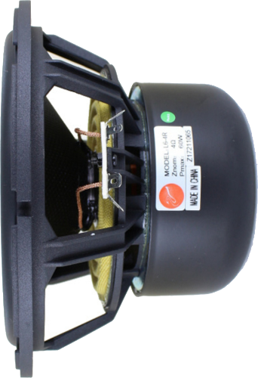
5”
4”
2”
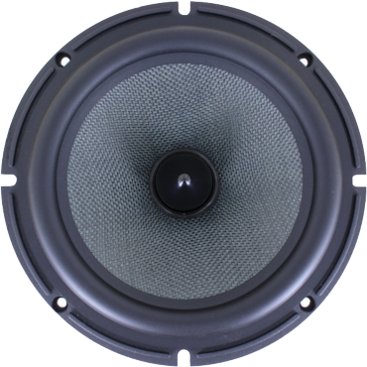
0”
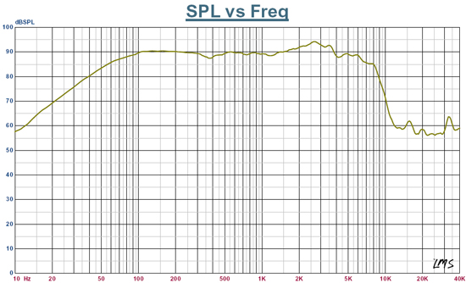  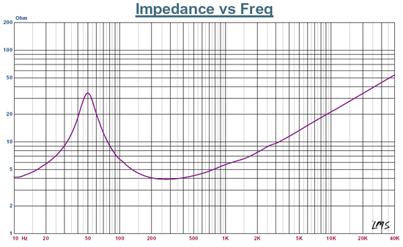 | Specification  Rated Impedance 4ohm  Resonant Frequency 50H z  Rated Power 30W  Max Power 60W  Sensitivity2.83v/1m） 88dB  Coil diameter 30mm  Coil Roll With 14.6mm  DC resistance 3.6ohm  coil wire High temp. SV wire  Coil frame High temp. Kapton  Magnet High perf. ferrite  Force coefficient 6.0N/A  Magnetic gap height 6.0mm  Xmax 4.3mm  Compliance 588uM/N  Mechanical Q value 3.856-  Electric Q value 0.44 -  Total Q value 0.4 -  Vibration Quality 17.3g  Equivalent volume 14.7L  Cabinet type Inverted
