Isodynamic Planar Tweeter RT1.3WE
4”
3”
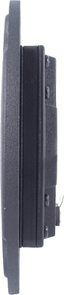
2”
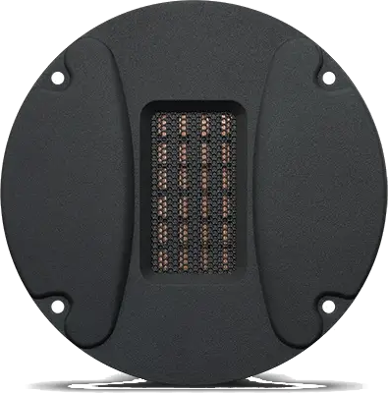
1”
0”
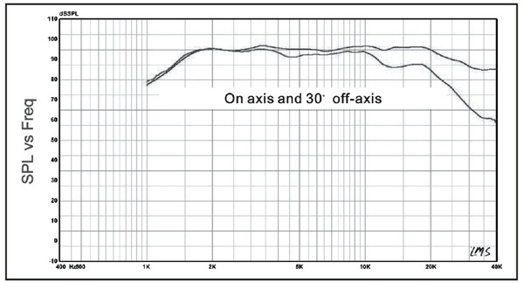 | An identifying mark:  Rated Impedance 6ohm  Resonant Frequency  1000H z  Rated Power 10W  Max Power 30W  Sensitivity(2.83v/1m） 92dB  DC resistance 5.4ohm  Magnet Neodymium  Suggested Crossover >2500Hz
